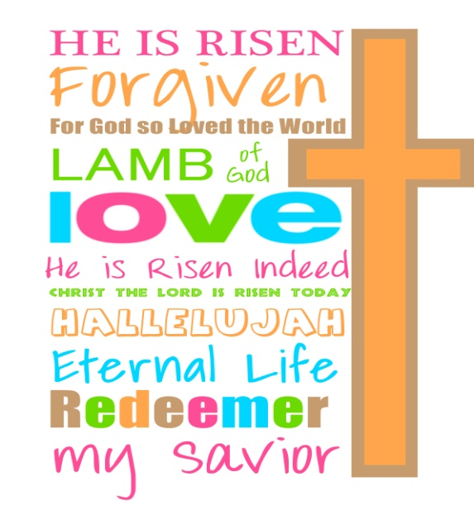
April 18, 2017
Easter Greetings Fifth Grade Families!
I hope your Easter celebrations were joyful. Thank you to those families who were able to worship at Grace. The choir did a great job leading worship and your efforts are appreciated
Two major school events dominate our week ahead. The first agenda item is the Science Fair. As you read this note, we have just completed our third egg drop. It’s really neat to each student holding a unique container. Although some containers use similar supplies or have comparable shapes, no two containers are identical. Not only has our class generated lots of enthusiasm for this project, but we have enjoyed the support from many spectators, known and unknown. At our last drop, our chapel buddies were there along with Mr. Bolig, Mr. Koehne, Mr. Mortensen, and Mrs. Fleish in addition to interested Concordia students. Final projects, which include the egg container and a written Lab Report, are due Thursday, April 20. Projects will be on display Thursday 6pm-8pm and students should plan to attend for at least thirty minutes that evening to share results and see the work of other classes.
The second big event this week is Friday which is Grandparents Day. All students will participate in fun half day of activities before 11:30 dismissal. It will be a short week, yet a full one. Despite only three days of instruction, we will work on poetry, a spelling lesson and our Lit Circles will meet Thursday
Finally for those NOT attending the Fine Arts festival on April 28th, please look in Tuesday Folders for a note about a field trip including a transportation form.
Together in the Risen Christ,
Mrs. Massmann

